# 

**Youtube Video URL** **1**

**Purpose** **1**

**Functionality** **1**

**How Tested** **2**

**Challenges/Lessons Learned** **3**

**Tradeoffs** **3**

**Citations** **4**

# 

# Youtube Video URL

<https://youtu.be/AkSzbgJabUg>

# Purpose

The purpose of this project is to create an automatic smart blinds system for businesses. It will keep track of the outside and inside temperatures, and lighting levels, and adjust the blinds accordingly. This can be useful for reducing energy consumption because it maximizes natural light while still reducing the amount of heat that will get in if it is a hot day. The device uses two photoresistors and two DHT sensors to detect the light and temperature levels. Based on this data, it runs a stepper motor (connected to the adjustment rod on the blinds) to adjust the blinds. It also has a bluetooth system to put the device into manual mode allowing users to override the automatic system. This is useful for times where they need the extra light regardless of the additional heat or if they want to close the blinds to make the room darker.

# Functionality

* The device starts in manual mode
* Using the bluetooth controller app on the Google Play Store, the 3 button will adjust the blinds into a more closed position.
* The 4 button will open the blinds further
* The blinds can not be opened more than a max 100% and closed less than 0%.
* To switch into automatic mode, you press the 2 button.
* The blinds will use data gathered from 2 DHT-11 temperature sensors and 2 photoresistors to adjust the blinds
* If it is dark outside, the blinds will close, unless it is hot inside, then they will stay open to allow for the window to be opened.
* If it is bright outside, the blinds will open, unless it is hot outside, then they will close a certain amount depending on how hot it is.
* If it is brighter outside than inside, and the temperature permits, the blinds will open to let more light in.
* The blinds have 5 levels of adjustment: 0%(fully closed), 25%, 50%, 75%, 100%(fully open)

|  |  |
| --- | --- |

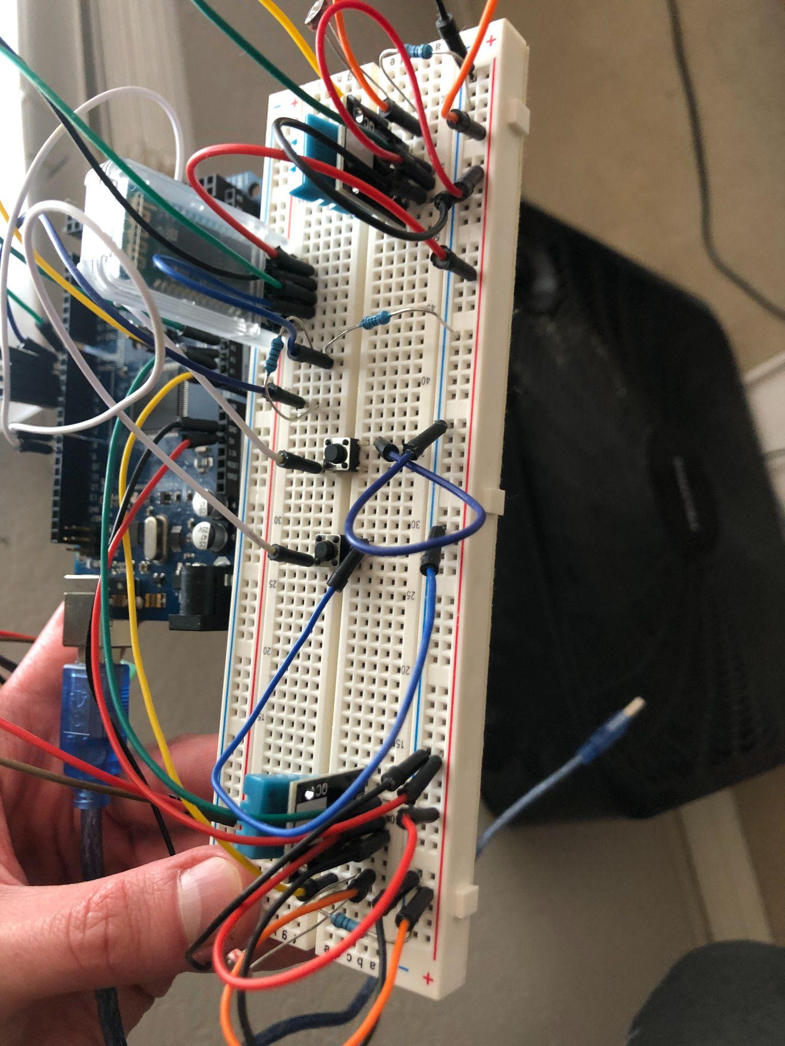

# How Tested

* The device was tested by using the app and switching in and out of manual mode.
* The different blinds levels were cycled through using manual mode to ensure the motor is working properly.
* The device was then switched into automatic mode and the device was put into different environments to trigger the sensors properly.
* In a bright cool room, the blinds opened all the way.
* Covering the outside light sensor (making it nighttime) made the blinds close.
* Covering the outside light sensor half-way made the blinds go to 50%.
* Covering the inside light sensor all of the way, and the outside one half way, the blinds open to 100%.
* Blowing hot air on the outside temperature sensor made the blinds close.
* Hot air on the inside temperature sensor made the blinds open (to allow for the window to be opened)

# Challenges/Lessons Learned

* It was a challenge to get the manual mode to work since it had to override the automatic system. It was not necessarily hard to do, but it was tedious since it had to stop other processes so that the phone app could take over.
* The most challenging part of this project was figuring out the criteria for how the blinds should automatically adjust based on the 2 temperature sensors, and 2 light sensors. The goal was to maximize the amount of natural light, but minimize the amount of additional heat that might be let in by having the blinds open.
* A lesson I learned was that the stepper motor should not be run purely off the arduino power. I learned this in class. Because of this, I went out and bought a 9v battery to run the stepper motor.
* I also had to learn how to use 2 DHT-11 sensors at the same time. I only worked with 1 sensor originally, so I had to look into it to figure it out. I used an ADAFruit library to use the DHT sensors.

# Tradeoffs

* Using a stepper motor is a tradeoff. The stepper motor is very slow so the blinds adjustments take a long time to complete. However, a regular motor would not have been able to have enough torque to twist the blinds adjustment rod. It would’ve needed to be geared down. The stepper motor was a more simple way of accomplishing the goal. And it doesn’t need to adjust very quickly anyways.
* I used a HC-05 bluetooth module which was very affordable, but is not compatible with Apple devices. This is not a great tradeoff to make for this device as a product. But, for a project it was simple to use and did the trick.
* The DHT11 sensors for getting the temperature are not very accurate. The temperature readings are +-2C which is not great if there are small temperature differences between the window and the room itself. A better temperature sensor would be good to use for a production version of the device.

# Citations

* <https://howtomechatronics.com/tutorials/arduino/arduino-and-hc-05-bluetooth-module-tutorial/> (for learning how to wire/use the bluetooth module)
* ADAFruit DHT-sensor-library